Full Stack Development with MERN
Project Documentation format

1. Introduction
Project Title: SkyWings- Flight Booking Application
Team Members: Rahul R (Full Stack Developer)

The SkyWings– Flight Booking Application is a full-stack web platform that enables travelers to search, compare, and book domestic/international flights online. The system provides real-time seat availability, secure booking and payment, and a dedicated admin panel for managing flights and bookings.
The FSD outlines the functional and technical behavior of the application and serves as a reference for developers, testers, and stakeholders.
2. Project Overview
- Purpose: To build a convenient online flight booking system where users can browse, evaluate, and purchase flight tickets digitally without visiting physical counters. The platform focuses on usability, real-time availability, and reliable decision-making.

- Key Features:
- Secure user registration and login
- Search and filter flights by origin, destination, date, airline & class
- Booking with passenger details and dummy payment
- View booking history and cancel reservation
- Admin dashboard for managing flights and bookings
3. Architecture
- Frontend: Developed using React with reusable components. Context API handles authentication and booking state. React Router ensures smooth navigation across pages.
- Backend: Developed using Node.js & Express.js with MVC structure. Routes handle incoming requests, controllers process logic, and models interact with the database.
- Database: MongoDB stores users, flights, and booking data using Mongoose schemas to define structure and relationships.

4. Setup Instructions
• Prerequisites: Node.js, MongoDB, Git, VS Code.
• Installation Overview:
Clone the project repository
Install dependencies for both frontend and backend
Configure environment variables (e.g., MongoDB URI)
Start the development servers
5. Folder Structure
• Client: Consists of all React‑based UI features — pages, components, CSS files, assets, and context providers.
• Server: Includes routes, controllers, models, and middleware that handle backend logic and database interaction.
6. Running the Application
To run the project locally:
- Frontend: npm start in the client directory.
- Backend: npm start in the server directory.
7. API Documentation
• The backend exposes several REST APIs for user, book, wishlist, cart, and admin operations.

Endpoint Method Purpose
/api/auth/register POST Register a new user
/api/auth/login POST Authenticate user and return JWT token
/api/auth/me GET Get logged-in user profile
/api/auth/profile PUT Update user profile

Flight Endpoints:

Endpoint Method Purpose
/api/flights GET Fetch all available flights
/api/flights/:id GET Get selected flight details
/api/flights POST Add new flight (Admin only)
/api/flights/:id PUT Edit/update flight details (Admin only)
/api/flights/:id DELETE Delete a flight (Admin only)

Booking Endpoints

Endpoint Method Purpose
/api/bookings POST Create a new booking
/api/bookings/my-bookings GET View user’s booking history
/api/bookings/:id GET Get booking details
/api/bookings/:id PUT Update booking / Change status
/api/bookings/:id/cancel DELETE Cancel a booking
/api/bookings/:id/reschedule PUT Reschedule flight booking

8. Authentication
Authentication in SkyWings– Flight Booking Application is handled securely on the backend using JWT (JSON Web Tokens) to ensure safe access to user accounts and admin privileges.
- Login credentials are verified against the database before any access is granted.
- Upon successful login, a JWT token is generated and stored in the browser (localStorage) to authenticate future requests.
- Passwords are secured using bcryptjs hashing, ensuring they are never stored in plain text.
- Every protected API request is validated using authentication middleware, which checks for a valid JWT token before allowing access.

Role-Based Access Control (RBAC) is implemented:
- Users (Travelers) can search flights, manage bookings, update profile details, and perform customer operations.
- Admin’s have elevated permissions such as adding flights, editing flight schedules, updating booking statuses, and managing users.
This ensures that each user only has access to features authorized for their role, maintaining security, privacy, and system integrity.

9. User Interface

• This section contains visual proof of functionality. Screenshots should be included for:

Homepage:

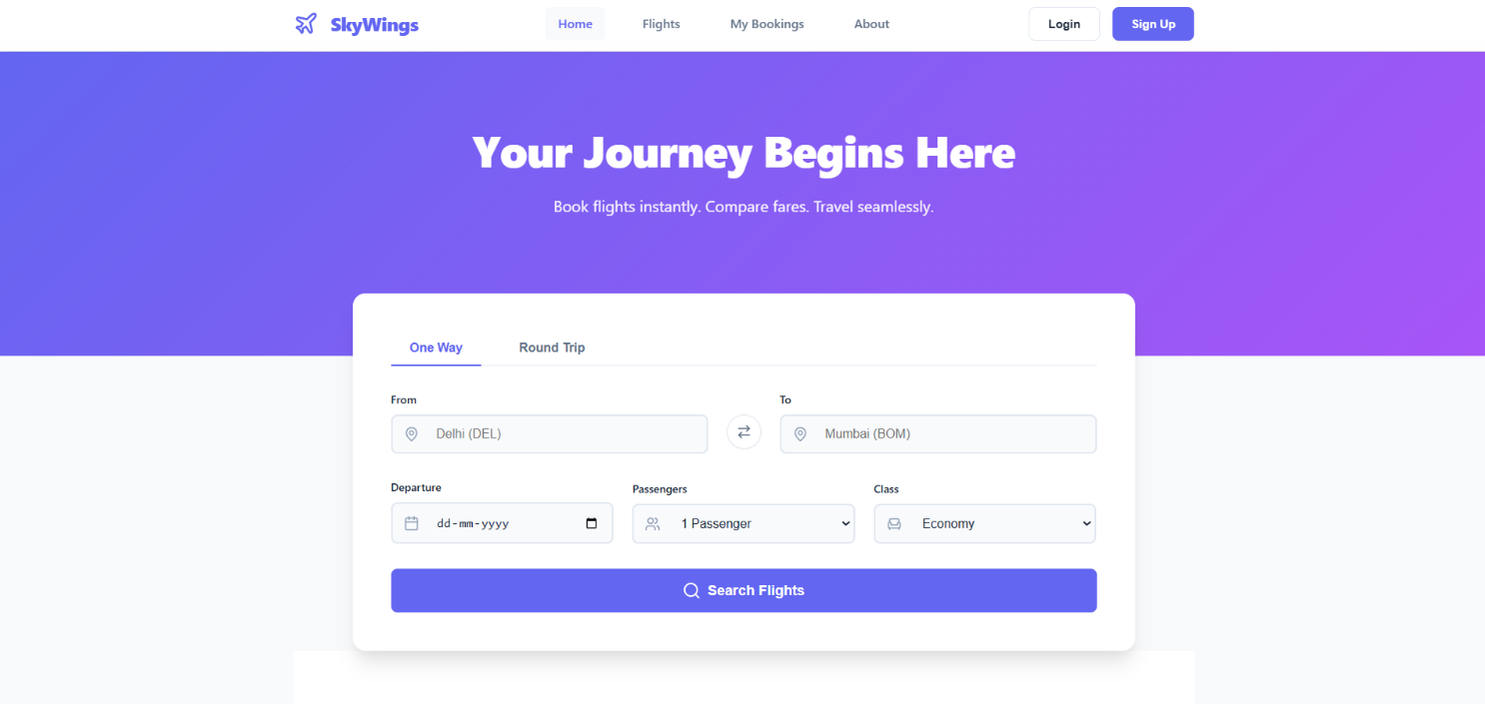

Flight Search Section:

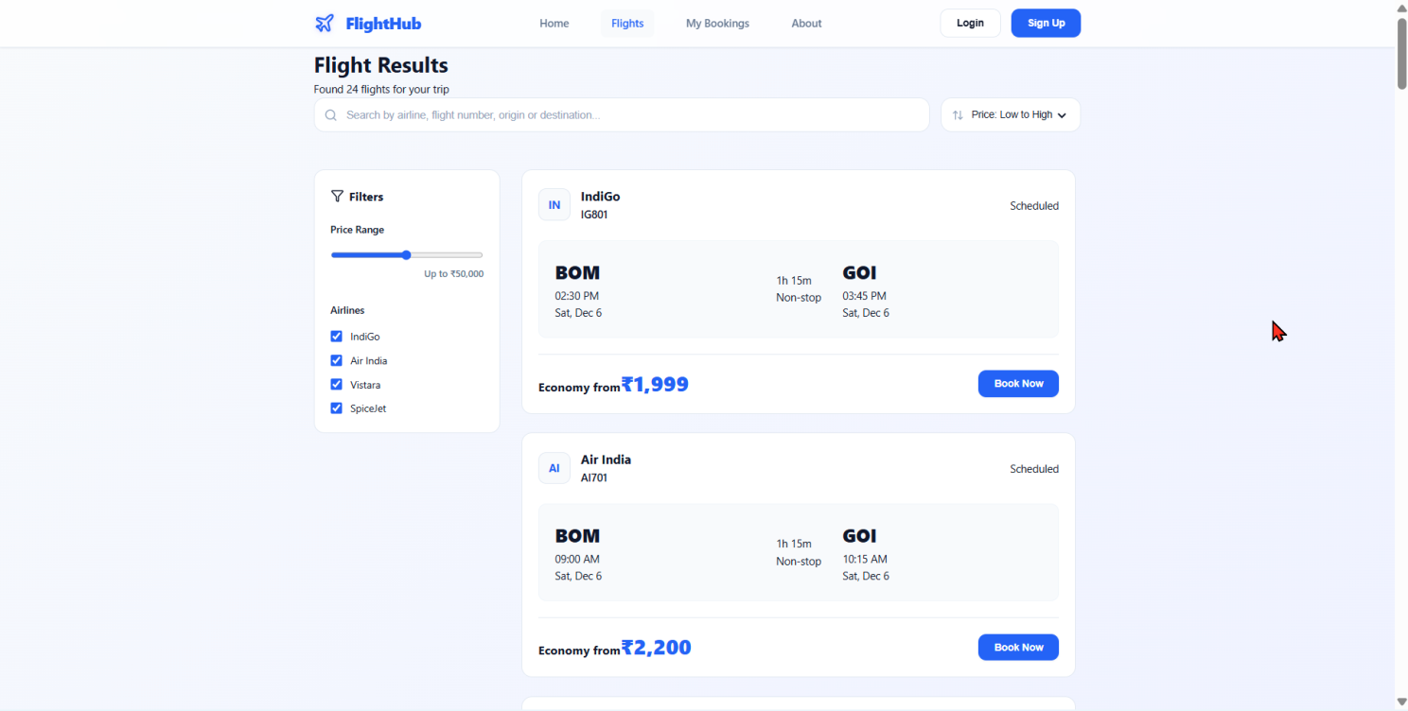

User Profile Section:

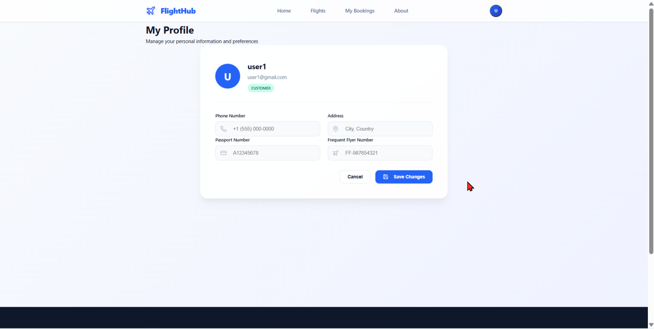

My Bookings:

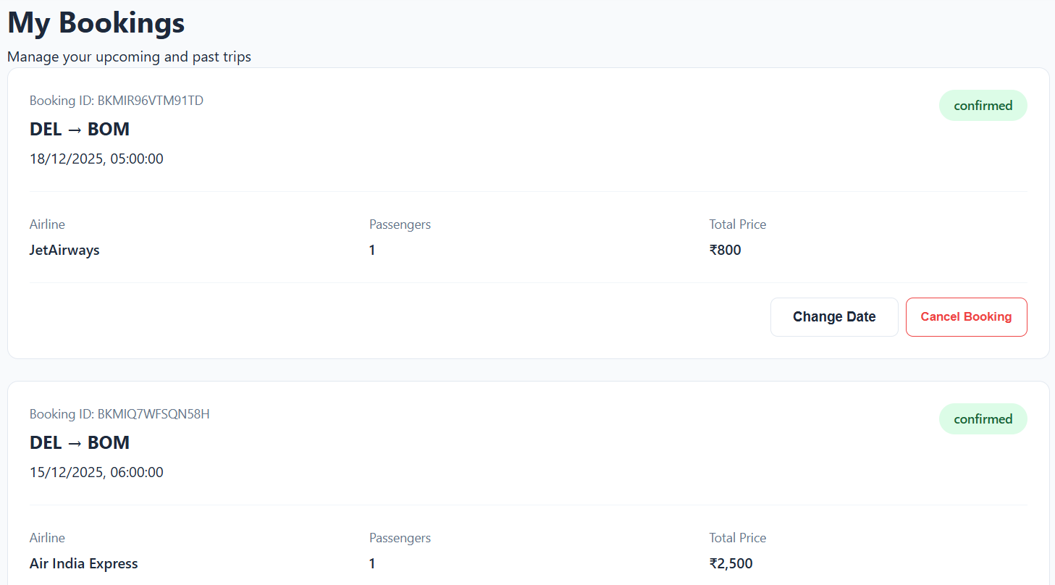

Register:

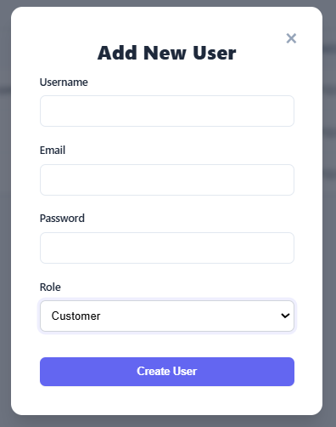

Login:

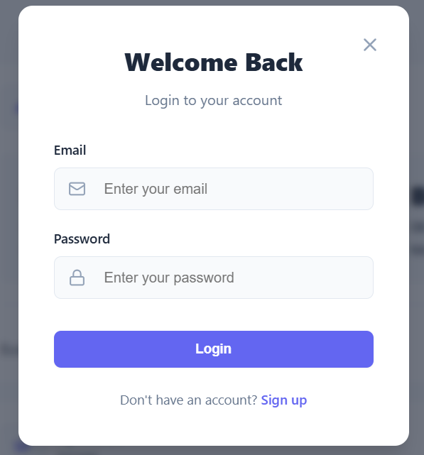

Admin Panel:

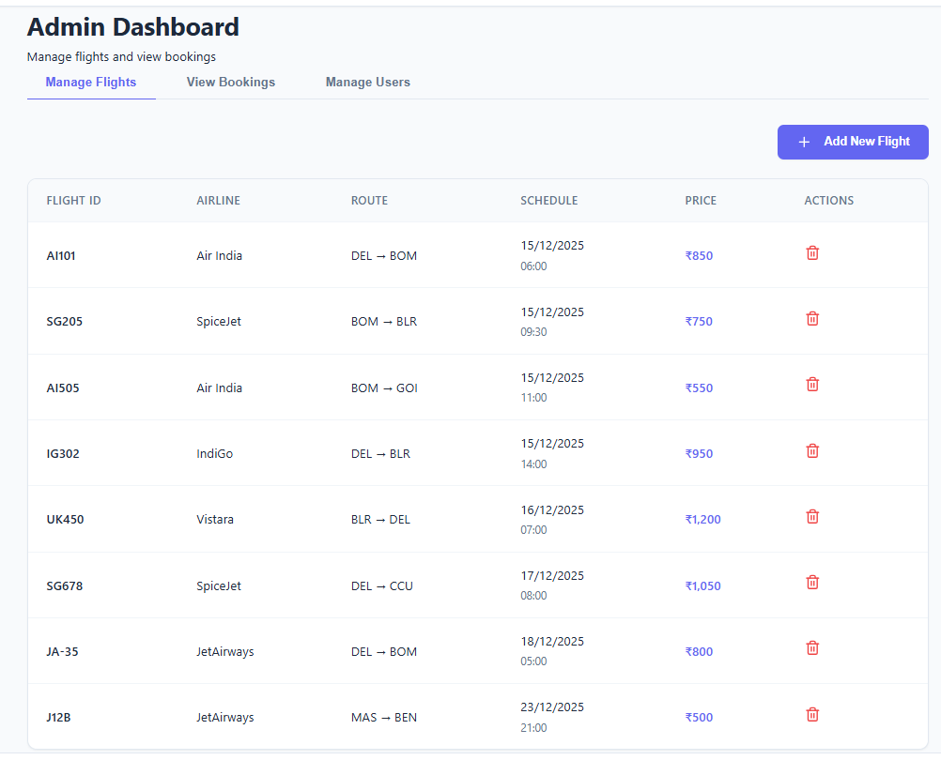

Add / Edit Flights (Admin)

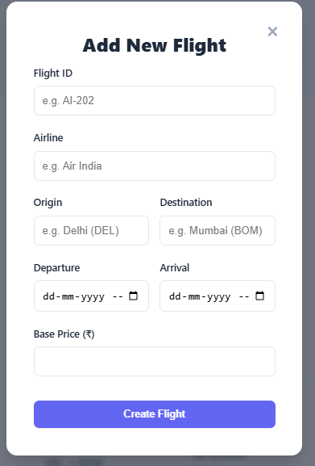

10. Testing
Testing was performed using:
- Manual UI testing for all user actions and admin actions
- Postman for API endpoints
- Debugging of flight search, profile update, booking functionality
11. Screenshots or Demo
• The application is fully functional and has been tested with real‑time usage. Screenshots of the working system have been captured and attached in the documentation, showing:
- Homepage
- Flight Search Section
- User Profile
- My Booking
- Login & Register process
- Admin dashboard
- Add / Edit Flight (Admin)
Demo Link:
https://drive.google.com/drive/folders/1gOpv6rXTujoETqmKrMHFsJLWjeYeqdHr?usp=sharing
12. Known Issues
Issue | Description
Dummy payment gateway | A dummy payment method is implemented; real payment gateway integration is not available yet
Seat allocation sync | Real-time multi-user seat lock not implemented

13. Future Enhancements
Future improvements that can make the platform more scalable and user-friendly:
Feature Purpose
Real Payment Gateway Enable online transactions
AI-based price prediction Help customers book at best price
Flight delay notification system Real-time updates
Mobile App (iOS / Android) Wider accessibility
Loyalty / Reward Program Customer retention

14. Conclusion

The SkyWings application successfully provides a user-friendly and modern approach for real-time flight search and booking. The modular architecture, secure authentication, and role-based dashboard effectively support smooth operations for both customers and administrators. The system is scalable and ready for integration of additional features in future phases.

